# C3- S7 PRACTICE

# Ex 1: Can I go to PNC?

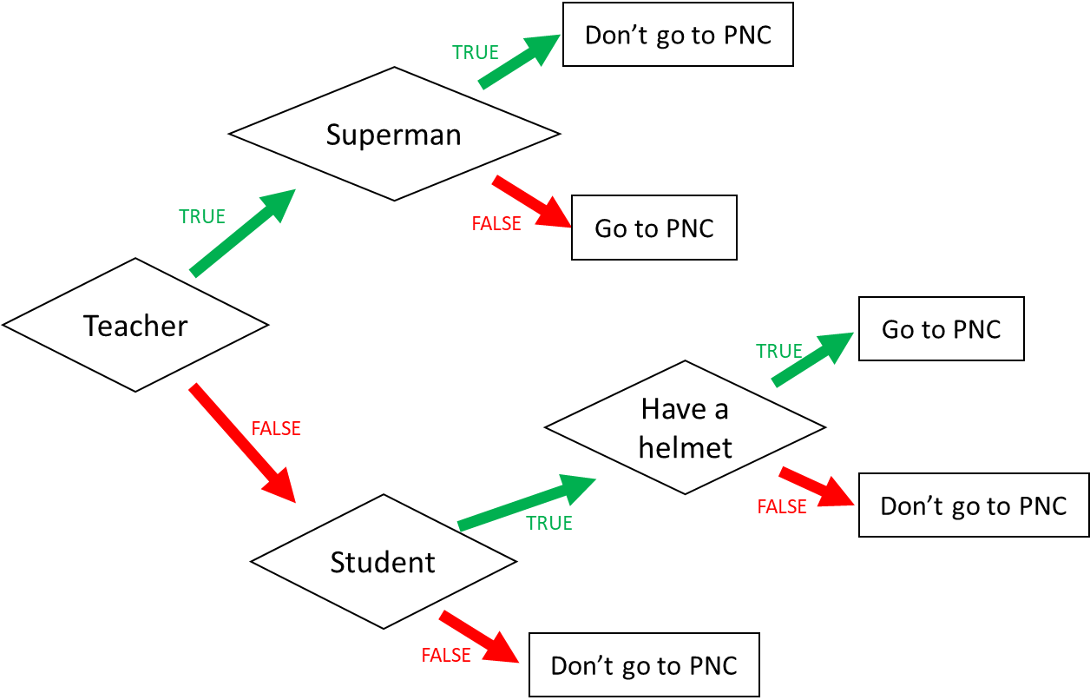

1. I am a teacher and I am superman, can I go to PNC? Don’t go to PNC
2. I am not a teacher and not a student, can I go to PNC? Don’t go to PNC
3. When can I go to PNC? (Express the condition using a Boolean expression)

I go to PNC if:

1 You are a teacher and not a superman, You go to PNC.

2 You are a student and have a helmet, You go to PNC.

3 You are a teacher and a student, You can go to PN.

Ex 2: What do I eat?

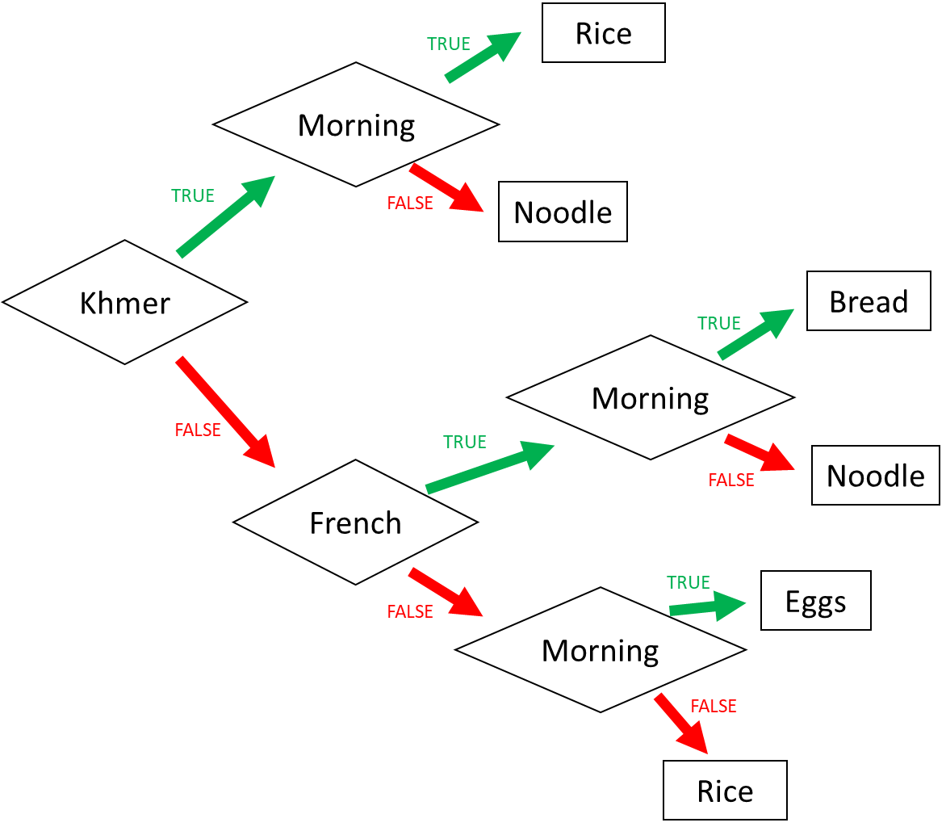

1. I am Khmer and it is the evening. What do I eat? Noodle

2. I am French and it is the morning. What do I eat? Bread

3. I am American and it is the morning. What do I eat? Rice

4. When do I eat rice? (Express the condition using a Boolean expression)

I eat rice if:

1 I am Khmer and Morning, Rice.

2 I am French and morning, bread

3 I am American and morning, eggs.

Ex 3: Do I go to the pool?

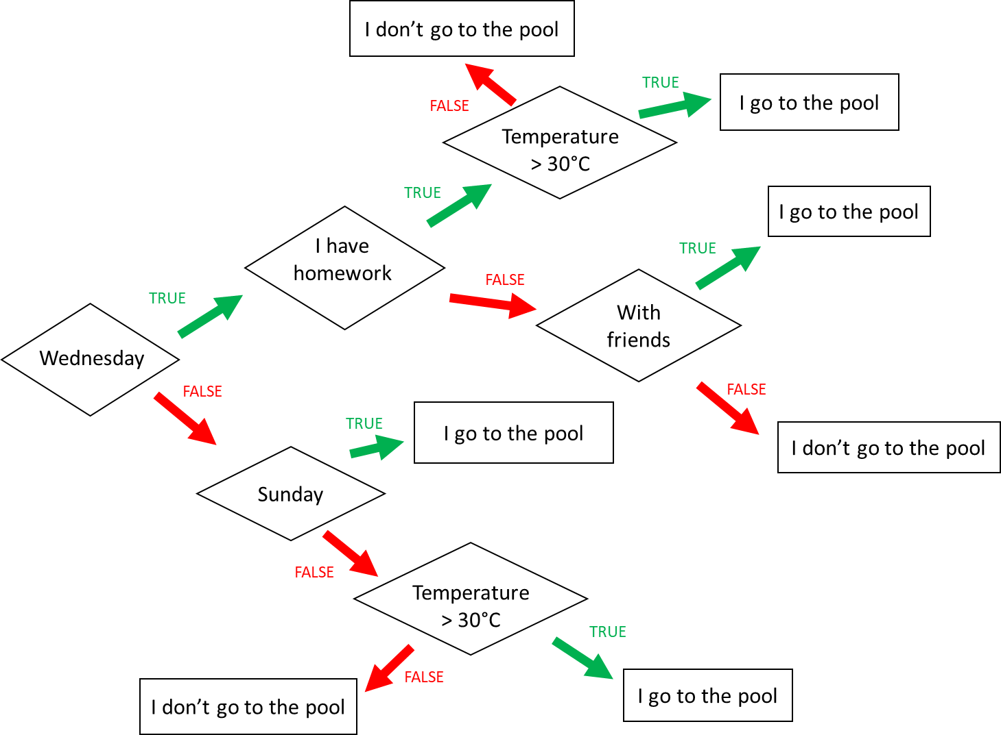

**Input 1 :**

* Wednesday
* Temperature = 31°C
* **Homework**

🡪 Do I go to the pool ?

No, you don’t.

**Input 2 :**

* Monday
* Temperature = 35°C
* I have no friend

🡪 Do I go to the pool ?

No, you don’t.

**Input 3 :**

* Wednesday
* I have **no** homework
* I’m with friends
* Temperature = 28°C

🡪 Do I go to the pool ?

No, you don’t.

When do I go to the pool ? (Express the condition using a Boolean expression)

I go to the pool if :

I go to the pool if

Wednesday AND homework AND temperature > 30°C OR

Wednesday AND no homework AND friends OR

Sunday OR

Not Wednesday AND not Sunday AND temperature > 30°C

Ex4: Do I create a Facebook account?

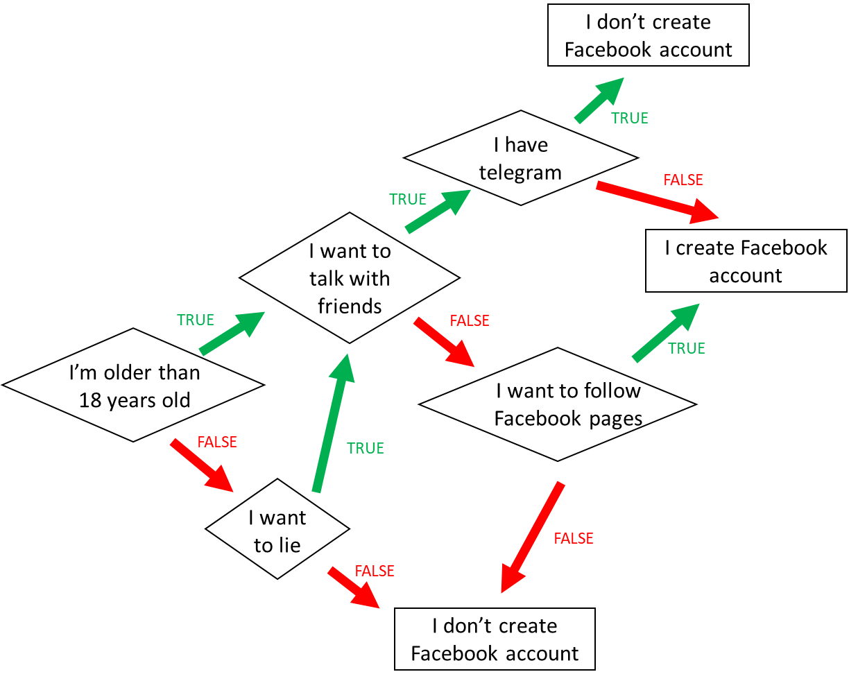

1. When do I create a Facebook account? (*Express the condition using a Boolean expression)*

I’m older than 18 years old and I want to talk with friends and I don’t have a telegram, I don’t create Facebook account.

I’m older than 18 years old and I don’t want to talk with friends and I want to follow Facebook pages, I create a Facebook account.

1. When **don’t I** create a Facebook account? *(Express the condition using a Boolean expression*

I’m not older than 18 years old and I want to talk with friends and I have a telegram, I don’t create Facebook account.

I’m older than 18 years old or I want to lie and I don’t create Facebook account.

I’m older than 18 years old and I want to talk with friends and I have telegram, I don’t create Facebook account.

Ex5: Create the chart flow

**Q1** Complete the char flow to follow those rules:

* If I am a girl and it is sunny, I wear a skirt
* If I am a girl and it is not sunny, I wear jeans
* If I am a boy and it is sunny, I wear a short
* If I am a boy and it is not sunny, I wear jeans

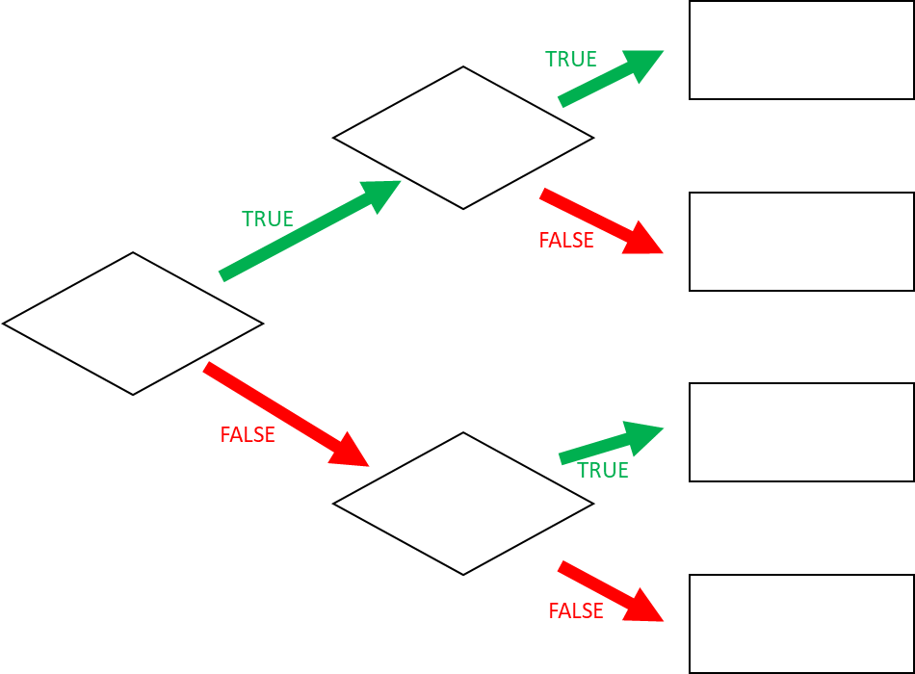

Girl

Sunny

Sunny

skirt

jeans

short

jeans

**Q1** When do I wear jeans? *(Express the condition using a Boolean expression)*

You are girl and not sunny.

You are not a girl and sunny.